National Enterprise Awards 2019 Application Form
LOCAL ENTERPRISE OFFICE OFFALY

Applicant Name: _________________________________
Insert name of client

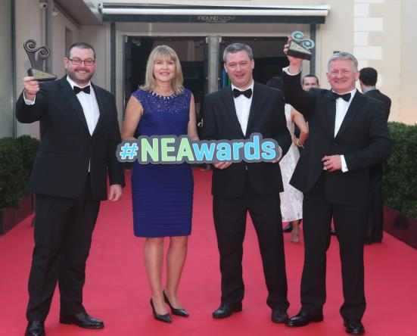

Please return your completed application form, together with a current Business Plan, sample of marketing material and financial statements to Local Enterprise Office Offaly, Offaly County Council, Áras an Chontae, Charleville Road, Tullamore by 4pm on Thursday, 14th February 2019.

2019 County Enterprise Awards – Your Chance to Shine!

Who can apply?

Client businesses that have received funding from the Local Enterprise Office. This may include any of the following types of funding:

- Feasibility Study, Priming or Business Expansion Grants
- LEO Innovation Investment Fund (LIIF)
- Irish Best Young Entrepreneur Competition (IBYE)
- Technical Assistance for Micro-Enterprises (TAME)
- Trading Online Vouchers

Applicants must employ 10 or less employees on a full time equivalent basis, as at 31/12/2017.

There are cash prizes to be won, great publicity for your business and an opportunity to represent the County at the National Enterprise Awards Final.

The Offaly County Enterprise Awards Ceremony will take place on Monday, 4 March 2019. The Awards Ceremony will be a lunchtime event in the Tullamore Court Hotel.

What to Do:
  - Download the form via www.localenteprise.ie (or email info@leo.offalycoco.ie for a soft copy of the application form)
  - Submit with a copy of the business accounts, and any other supporting information such as sales brochure, photographs, business plan.
  - Submit all by Thursday, 7 February 2019 at 4pm.
  - Mark your diary for the Awards Ceremony on Monday, 4 March 2019.

In the Local Enterprise Office we know what great businesses are out there, but make sure the rest of the County and your potential customers do too!

If you require assistance with the completion of the competition form, please do not hesitate to contact us on 057 93 57480. Remember, closing date for applications is THURSDAY, 14TH FEBRUARY 2019 at 4pm.

GENERAL INFORMATION

Name of Applicant: __________________________________________________________

Address: __________________________________________________________

____________________________________________________________________________

Region: __________________________________________

Legal Status: (Tick one) Sole Trader Partnership Limited Company

Date of Commencement of Business: _________________________ ______

Phone: _______________________ Business ______________________ (Mob)

Website: _____________________ E-mail:____________________________

Business Information
What product or service do you supply?

Describe your own background and why you set up in business?

What do you see as the key strengths of your business?

In what way and when, did your Local Enterprise Office help your business? (Please include the year, type and level of support i.e. Grant aid and /or Training Supports)

Has this business been grant aided by any other government agency such as Enterprise Ireland, An Bord Bia, Leader Partnership, Inter Trade etc . (If so give details i.e. Agency, Year, Grant Amount, Type etc)

Marketing Your Business
Describe what is different or innovative about your product or service?

Is your customer base local, regional, national, international? Please give details.

How do you market your business?
Are there potential new markets for your business and how do you plan to take advantage of these opportunities?

Social Media
What forms of social media do you use to promote your business and describe any campaigns you have undertaken?

Technology
How do you use technology in your business?

The Future of your Business
What long-term plans do you have for your business and how do you see it growing and developing over the next 3 years?

What do you see as the key threats/weaknesses to your business? How do you propose to address them?

Employment Details

 | 31/12/2016 | 31/12/2017 | 31/12/2018 | Projected 2019
Full Time

Part Time

Financial Details
Business Growth | 2016 | 2017 | 2018 | Projected 2019
Annual Sales

Net Profit

Investment | 2016 | 2017 | 2018 | Projected 2019
Own Funds

Loans

Grants

TOTAL

Please provide short description of your business for inclusion in the NEA brochure – Max 50 words
SAMPLE WORDING FOR ILLUSTRATION - BROCHURE DESCRIPTION
Cork (South): Start of word count: Haven Bay Care Food Ltd. supplies a frozen range of restaurant-quality readymade meals under the 'Kinsale Gourmet' brand. The meals are handmade in Kinsale by its six staff for the retail and foodservice markets. Currently supplying all major retail multiples in Ireland, the company has also begun exporting to the UK. End of word count. Promoter: Owen O’ Brien E: info@kinsalegourmet.ie W: kinsalegourmet.ie

(Please return your completed application form, together with a current Business Plan, sample of marketing material and financial statements such as your last end of year accounts / current year’s management accounts to your Local Enterprise Office by 4pm on 14th February 2019.

Signed: ___________________________________

Date: ___________________________________

Appendix 1 - Guidelines for judging criteria and marking system

LEO Name

Promoter

Address
Region

Date Business Established

Telephone

Email

Website

Social Media Details

Business Plan | 15 | Total Marks
- Management capability / staff structure
- Competitiveness
- Growth potential
- Employment potential
- Business strategy
Marketing | 20
- Marketing strategy
- Company’s success in national and export markets
- Growth in sales revenue this year over previous years
- Responsiveness to market trends
Finance | 25
- Financial commitment of the owner
- Profitability of the company
- Strength of the balance sheet
- Net assets of the company
Technology & Innovation | 20
- Use of technology
- Innovation in business e.g. finance, production, marketing, HR etc.
Entrepreneurial Skills of Promoter | 20
- Leadership qualities
- Vision and drive
- Commitment
- Entrepreneurial capability (risk taking etc)

TOTAL (out of 100) ________

